Initial circuit used for testing:

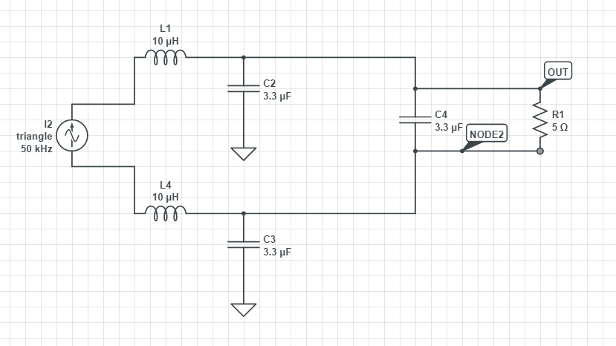

Current through the resistor R1:

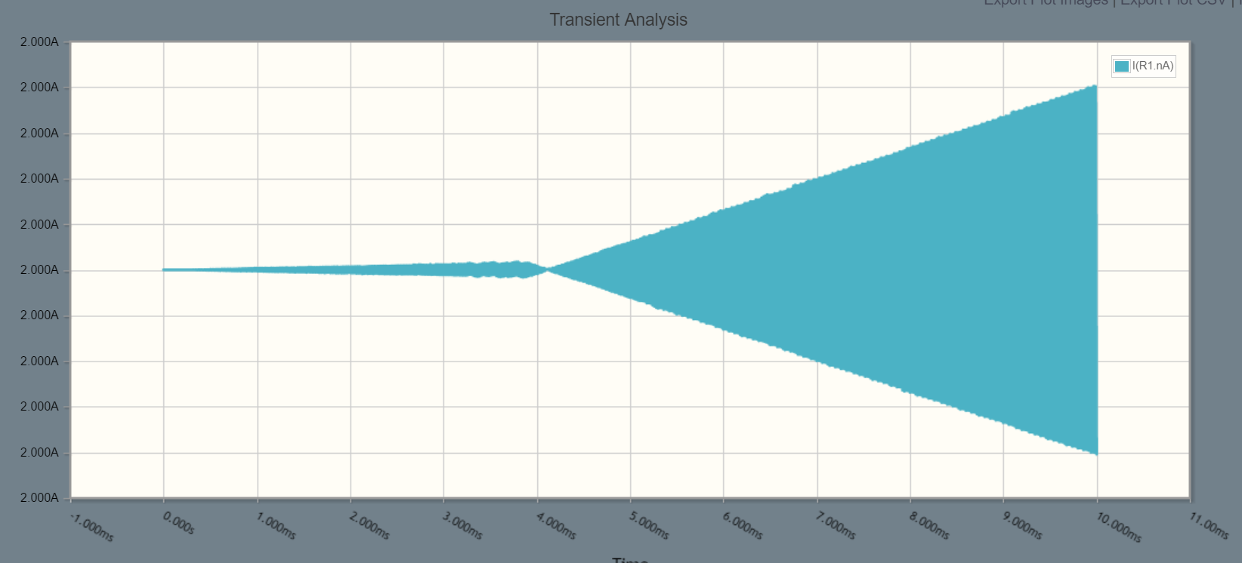

Note: The current Range.

On replacing the inductor by 100uH; there is almost no effect:

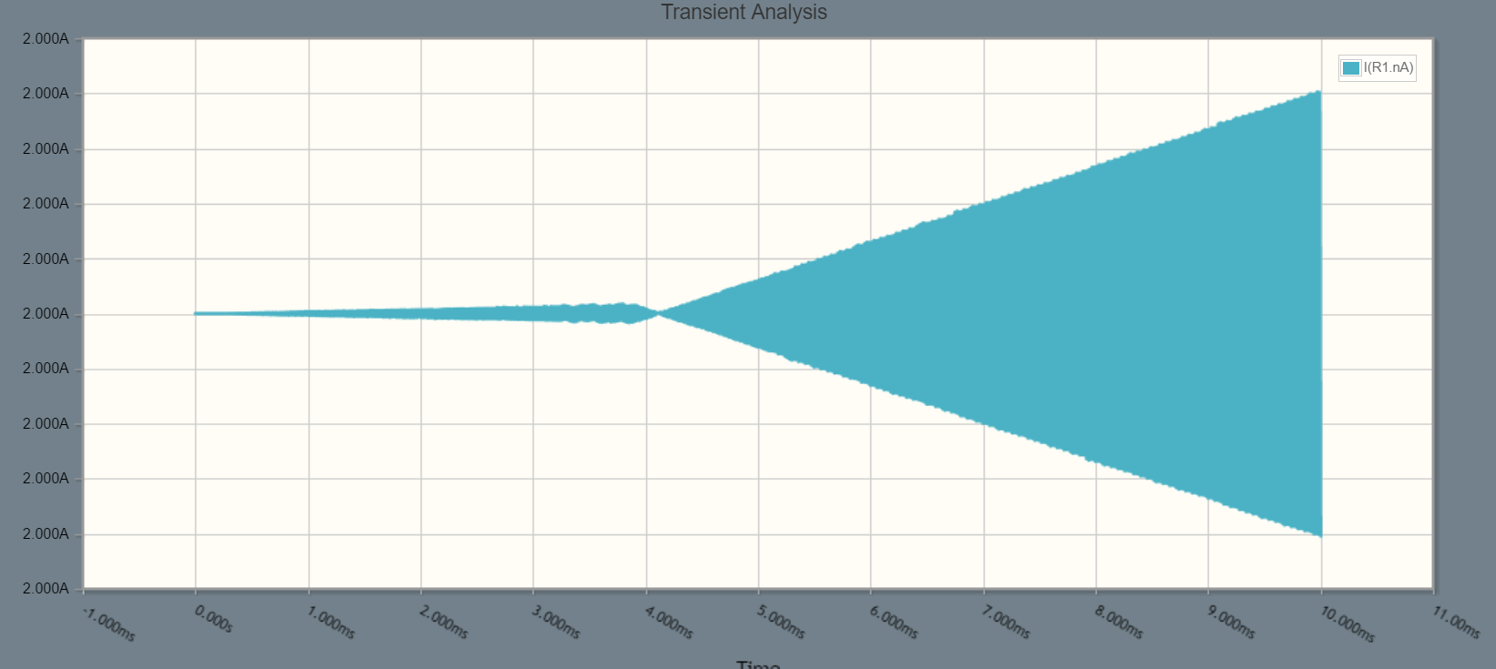

Making it to 33uH also does not seem to produce much effect:

